Maps Show Humans’ Growing Impact on the Planet
A new study has found a few distressing developments, but also some signs of hope.
View Images
A new study has found that humans' impact on the environment has grown, but slightly slower than expected. In this map, the orange places are those that face the highest pressure from humans. The blue areas face the least pressure.
COURTESY OSCAR VENTER
By Betsy Mason
PUBLISHED AUGUST 23, 2016

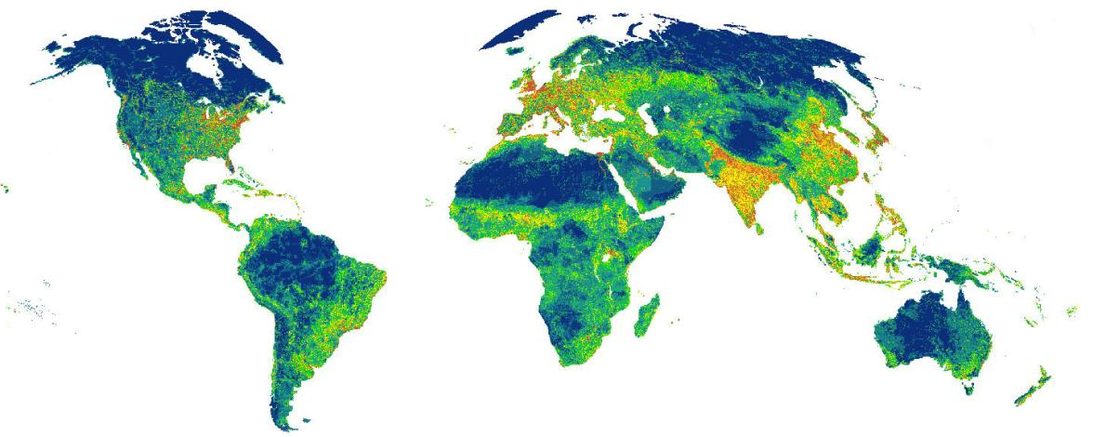
The impact humans have on the environment has grown substantially in the last 16 years—so much so that a new study concludes three-quarters of Earth’s land surface is under pressure from human activity. But the research also shows that humanity’s footprint on the planet hasn’t grown as fast as the overall population, and that may give conservationists cause for hope.
The study, published Tuesday in the journal Nature Communications, is based on analysis of satellite imagery and other data from 1993 and 2009. Researchers sought to rigorously map our impact on the global environment—called the human footprint—and how it has changed. They found that while the human footprint has not grown in direct proportion to population or the economy, some of the most intense pressure is being felt in places with the highest diversity of plant and animal life.
It’s become clear that humans are modifying the planet on a very large geological scale, says the study’s lead author, forest conservation scientist Oscar Venter of the University of Northern British Columbia. “We thought the timing was right to get a better understanding of where the last wild places on the planet are and how those places have contracted over the last two decades and how the footprint has expanded into them,” he says.
Vi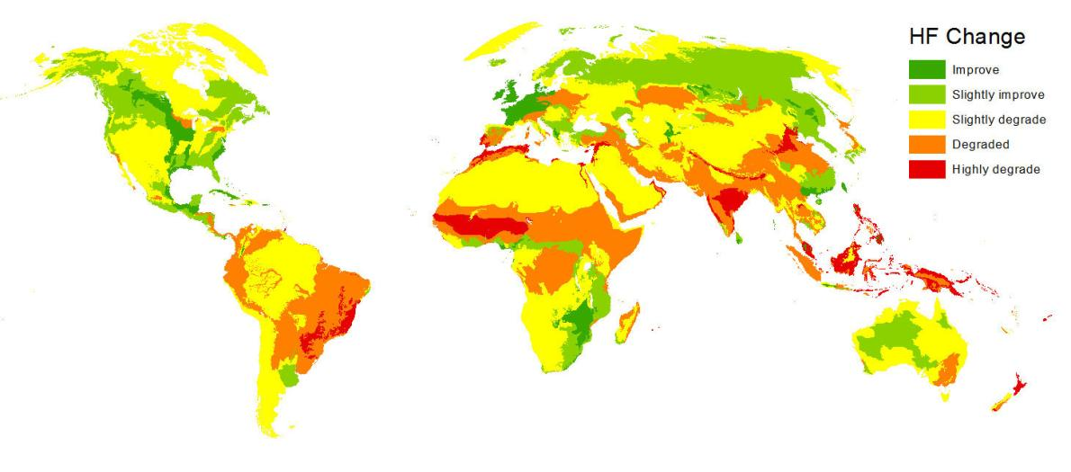ew Images
This map shows where humans' impact on the environment increased or decreased from 1993 to 2009.
COURTESY OSCAR VENTER
The new study is part of a growing research trend that capitalizes on improvements in satellite technology to map and monitor human activities such as deforestation, oil drilling, and movement of refugees. A recent study in Science used satellite data to map poverty. And as sensors become more sensitive, resolution improves. That, combined with more comprehensive satellite coverage, means scientists are able to map how all of these things change on finer and shorter scales, which is what Venter’s team did with the human footprint.
Building on the first comprehensive human footprint analysis published by the Wildlife Conservation Society in 2002, Venter and his colleagues used various kinds of satellite data to analyze eight different categories of human impacts, including the extent of built environments, cropland and pasture land, population density, nighttime lights, roads, railways, and navigable waterways. They also used census data for population density and the gROADS project to track roads.
For every square kilometer of land on Earth (excluding Antarctica), each category was scored according to its impact on the environment relative to the other categories. The researchers then combined these scores for each square kilometer for 1993 and 2009, and looked at how things changed.
Much of what they found was predictably depressing. For example, in 1993, just 27 percent of the land had no measurable human footprint. By 2009, that had grown by 9.3 percent, or 23 million square kilometers. Most of the remaining footprint-free land was in places that aren’t good for agriculture or cities, such as the Sahara, Gobi, and Australian deserts, the most remote portions of tropical rainforests in the Amazon and Congo, and the tundra. (You can explore the results online withinteractive footprint maps, and the maps and data are all publicly available.) The upside of the findings is that while population increased by 23 percent, the average score for the human footprint increased by just 9 percent. Even more promising is the fact that during that same 16-year period, the global economy has grown 153 percent, 16 times the rate of footprint growth.
This is encouraging and potentially very important, says research ecologist Samuel Cushman of the U.S. Forest Service’s Rocky Mountain Research Station. “We are in an age of extinction, but the difference between a truly mass extinction and just broad-scale extinction could hinge on this linkage between how fast the human footprint grows and if it is less than population growth or more than population growth.”
But the news is not uniformly good. Human pressure on the environment is distributed unevenly, and while some wealthier regions are showing a modest decrease in human impact, other parts of the world have experienced increasingly intense pressure. The footprint more than doubled in areas such as the New Guinea mangroves and the Purus Varzearain forest in the Amazon, and it jumped more than 1,000 percent in theBaffin coastal tundra. The Torngat Mountain tundra saw an increase of more than 10,000 percent.
Many of these areas experiencing the most pressure are also among the most biodiverse places on Earth. Among the hardest hit are areas with more than 1,500 plant species and areas with a at least 14 vertebrate species that are classified as threatened.
“When we looked at the most species-rich parts of the planet, the biodiversity hotspots, previously we thought about 15 percent of [their extent] was still natural. But our map of the human footprint showed actually only 3 percent of biodiversity hotspots are still natural,” Venter says. “This is really important because this is the most biologically valuable real estate on the planet. This is where we have unusually high concentrations of species that you just don't see anywhere else.”
Things look a little better for areas with the highest concentration of bird, mammal, and amphibian species, such as the Amazon Basin, which is still largely free from human impact. However, the researchers found that footprint-free territory within these biodiverse areas has rapidly declined since 1993.
These results suggest that the best conservation strategy may be to focus protection efforts on these species-rich areas and on remaining swaths of wilderness.
“They’re quite unique, and once they’re gone, they’re really gone,” Venter says. “I think looking at the parts of the planet that are still wild and finding ways of keeping them as they are, keeping them free of humans, should be something that we're really thinking about.”

DOK Level 2:
Summarize using “Sum It Up!” Worksheet below:
Sum It Up!
- Create an A + B + C topic sentence by combining the information from the three boxes below.
A  Activity or Lab | B  Strong Verb | C  Big Idea

- Write down 4-5 main ideas/facts from what you read that support the big idea in your topic sentence.

Fact Outline (important information)

Verb Bank
Specifies | Identifies
Elaborates | Illustrates
Extends | Clarifies
Proposes | Defends
Dismisses | Demonstrates
Justifies | Explores
Investigates | Shows
Analyzes | Suggests
Affirms | Supports
Explains | Chronicles
Student Choice:

Transition Words
Agreement / Addition / Similarity | Opposition / Limitation / Contradiction | Examples / Support / Emphasis | Conclusion / Summary / Restatement | Time / Chronology / Sequence
in the first place | although this may be true | in other words | as can be seen | at the present time
not only ... but also | in contrast | to put it differently | generally speaking | from time to time
as a matter of fact | different from | for one thing | in the final analysis | sooner or later
in like manner | of course ..., but | as an illustration | all things considered | at the same time
in addition | on the other hand | in this case | as shown above | up to the present time
coupled with | on the contrary | for this reason | in the long run | to begin with
in the first place | at the same time | to put it another way | given these points | in due time
equally | in spite of | that is to say | as has been noted | as soon as
identically | although this may be true | with attention to | as can be seen | as long as
uniquely | in contrast | in other words | generally speaking | in the meantime
like | be that as it may | to put it differently | in the final analysis | at the present time
3. Write your summary paragraph below. Start by coping you’re A + B + C topic sentence. Then turn each fact or main idea from the box above into a sentence. Use transition words (http://www.smart-words.org/linking-words/transition-words.html ) to help improve sentence fluency. If helpful, add on explain sentences (for example, this caused, this is important because…). No closing sentence is necessary.

____________________________________________________________________________________________________________________________________________________________________________________________________________________________________________________________________________________________________________________________________________________________________________________________________________________________________________________________________________________________________________________________________________________________________________________________________________________________________________________________________________________________________________________________________________________________________________________________________________________________________________________________________________________________________________________________________________________________________________________________________________________________________________________________________________________________________________________________________
__________________________________________________________________________________________________________________________________________________________________________________________________________________________________________

DOK level 3

Watch the video “Human Activities That Threaten Biodiversity” 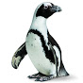

California Academy of Sciences
https://www.youtube.com/watch?v=2RC3Hsk90t8

Based on the article and the video write three paragraphs on the quote “No two things can occupy the same place at the same time.”
To complete this portion you will need to organize your thoughts. That’s right – outline time!
Let’s break it down into three ideas you want to cover:
- ____________________________________________________________________________________________________________________________________________________________
- ____________________________________________________________________________________________________________________________________________________________
- ____________________________________________________________________________________________________________________________________________________________
Now find some supporting evidence for each idea; remember these are your notes so you can short hand and abbreviate Remember to use evidence from both sources, the article and the video.
- ____________________________________________________________________________________________________________________________________________________________
- ____________________________________________________________________________________________________________________________________________________________
- ____________________________________________________________________________________________________________________________________________________________

Use your Sum-it-Up to help you. Each paragraph needs 3-5 sentences.
____________________________________________________________________________________________________________________________________________________________________________________________________________________________________________________________________________________________________________________________________________________
____________________________________________________________________________________________________________________________________________________________________________________________________________________________________________________________________________________________________________________________________________________
____________________________________________________________________________________________________________________________________________________________________________________________________________________________________________________________________________________________________________________________________________________
____________________________________________________________________________________________________________________________________________________________________________________________________________________________________________________________________________________________________________________________________________________
____________________________________________________________________________________________________________________________________________________________________________________________________________________________________________________________________________________________________________________________________________________
____________________________________________________________________________________________________________________________________________________________________________________________________________________________________________________________________________________________________________________________________________________
____________________________________________________________________________________________________________________________________________________________________________________________________________________________________________________________________________________________________________________________________________________
____________________________________________________________________________________________________________________________________________________________________________________________________________________________________________________________________________________________________________________________________________________
____________________________________________________________________________________________________________________________________________________________________________________________________________________________________________________________________________________________________________________________________________________
____________________________________________________________________________________________________________________________________________________________________________________________________________________________________________________________________________________________________________________________________________________
____________________________________________________________________________________________________________________________________________________________________________________________________________________________________________________________________________________________________________________________________________________

